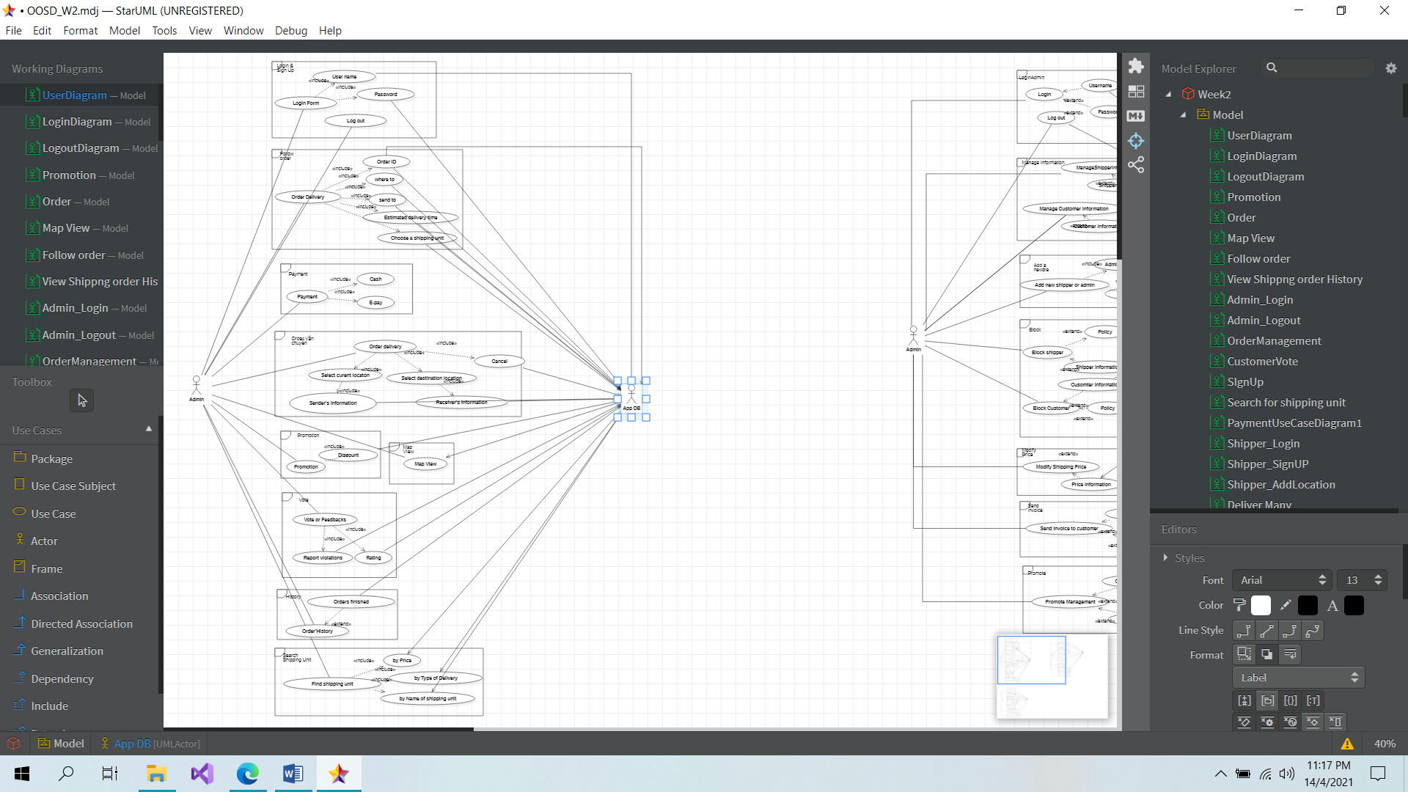**Overview Customer usecase**

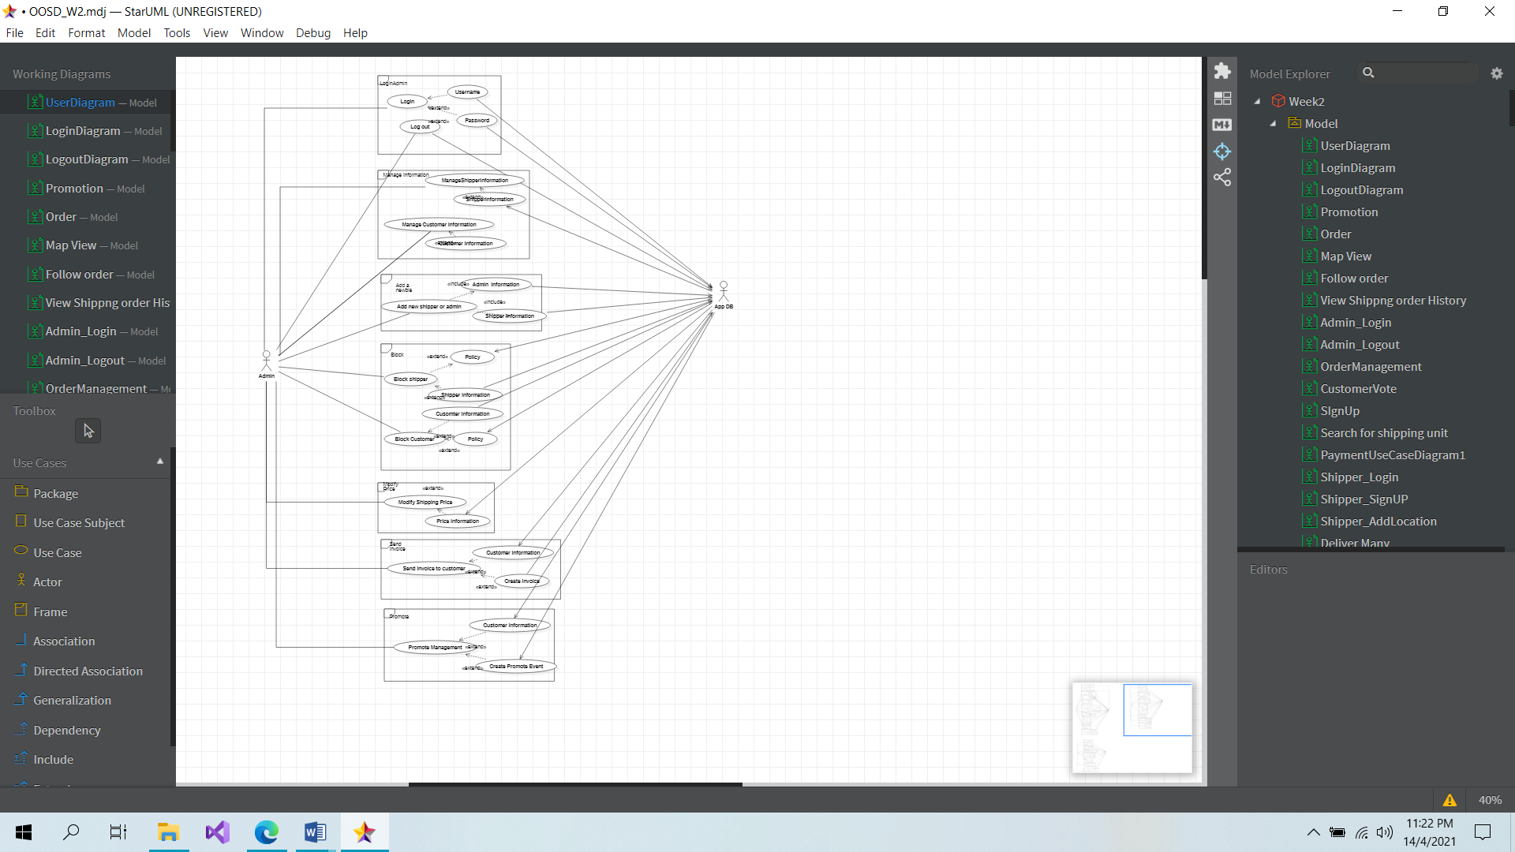**Overview Admin usercase**

**Overview Shipper usercase**

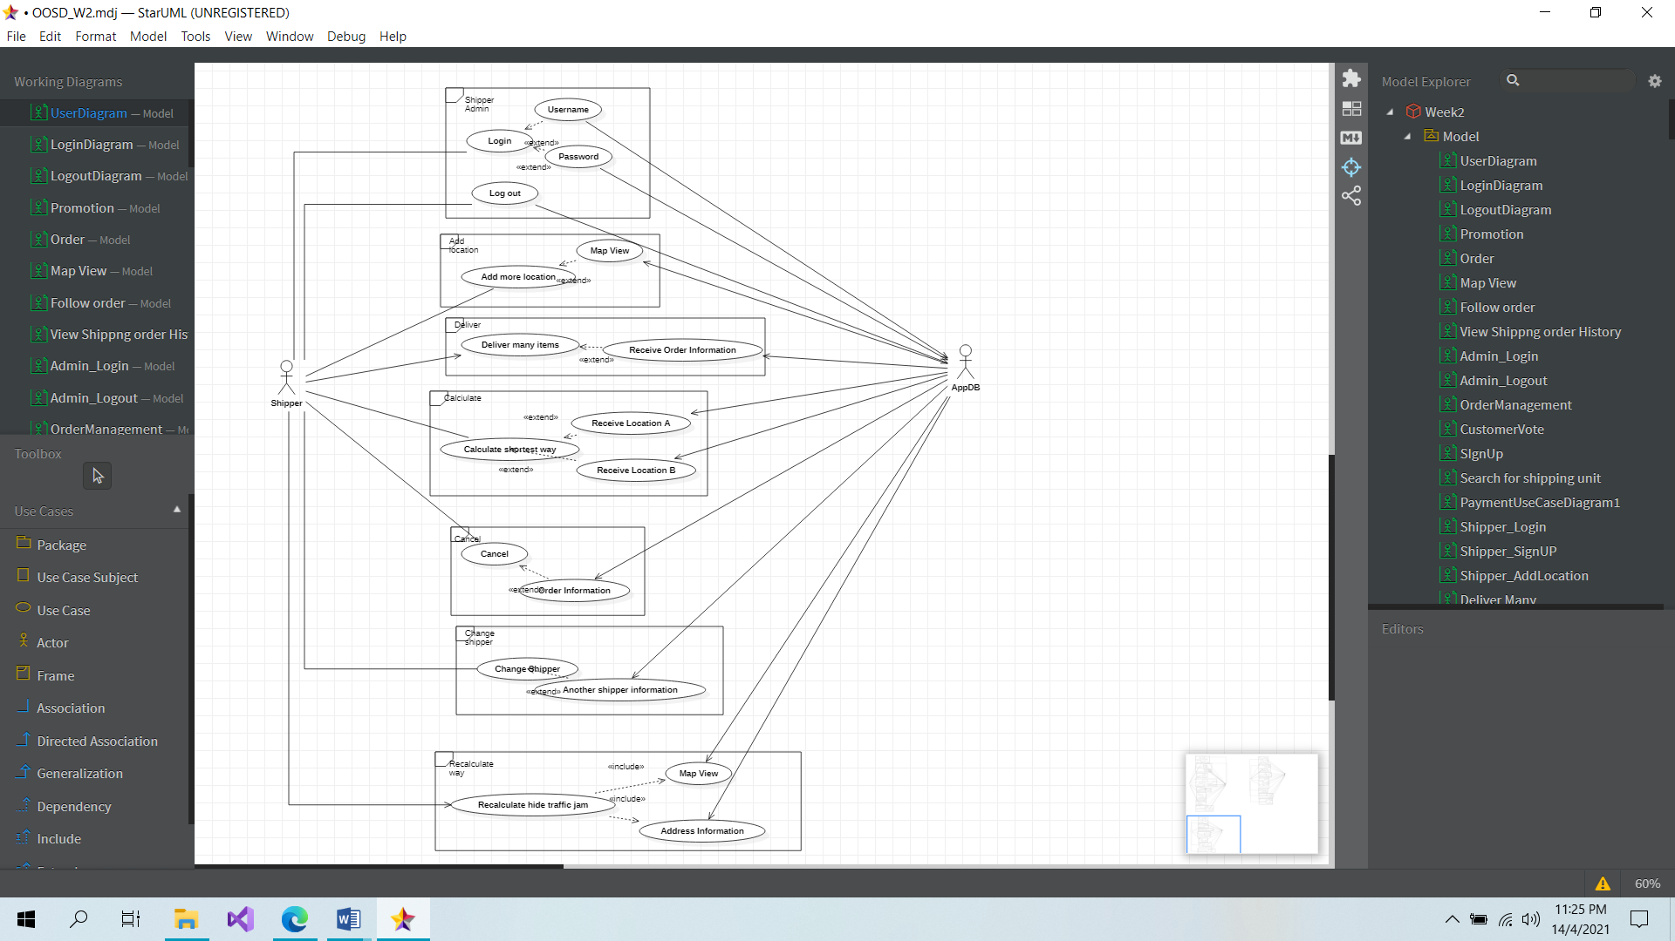

**CUSTOMER SIDE**

**User usecase Login**

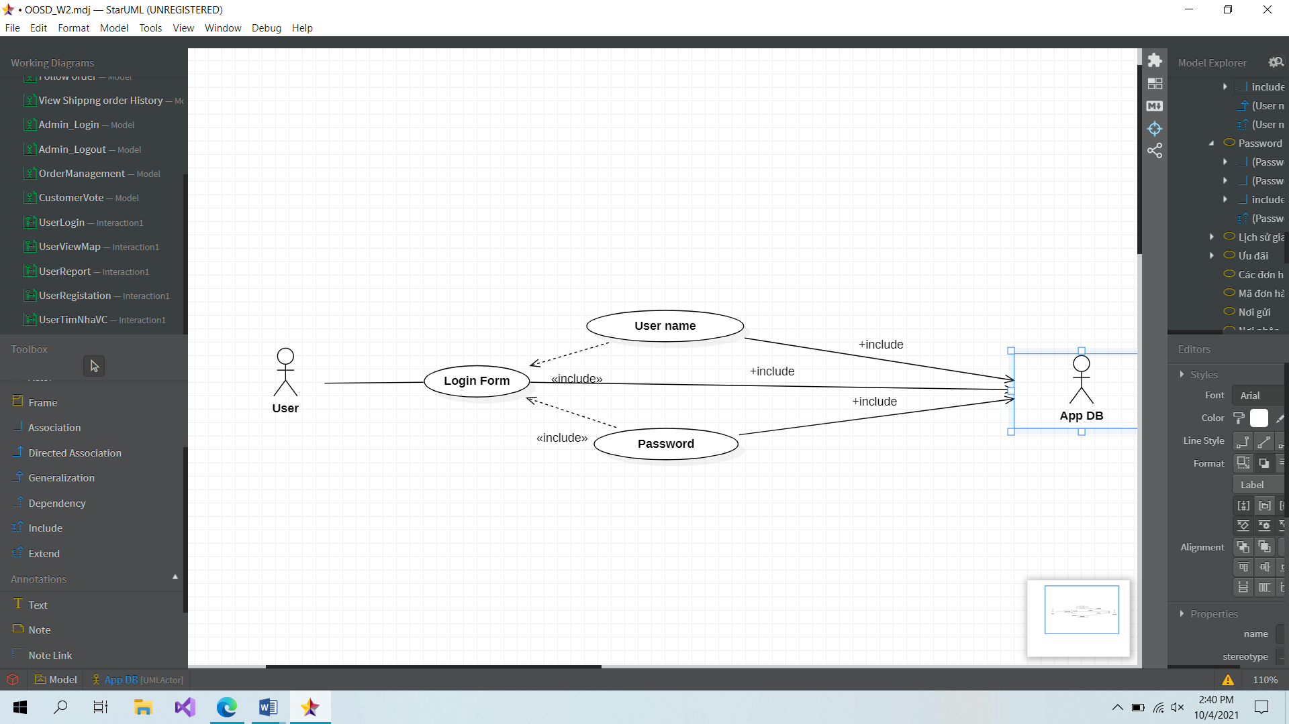

|  |  |
| --- | --- |
| **User usecase Login** | |
| **Actors** | User, Database |
| **Description** | An user can log in their account into the system based on database by inputing their username/email and password in the login form |
| **Data** | Users (database) |
| **Stimulus** | Interface including form and button |
| **Response** | User’s home page |
| **Comments** | The user must have a valid account and input correctly into the form. The user may have to confirm their account by using email/phone verification such as phone call, SMS, … in some system |

**User usecase Sign up**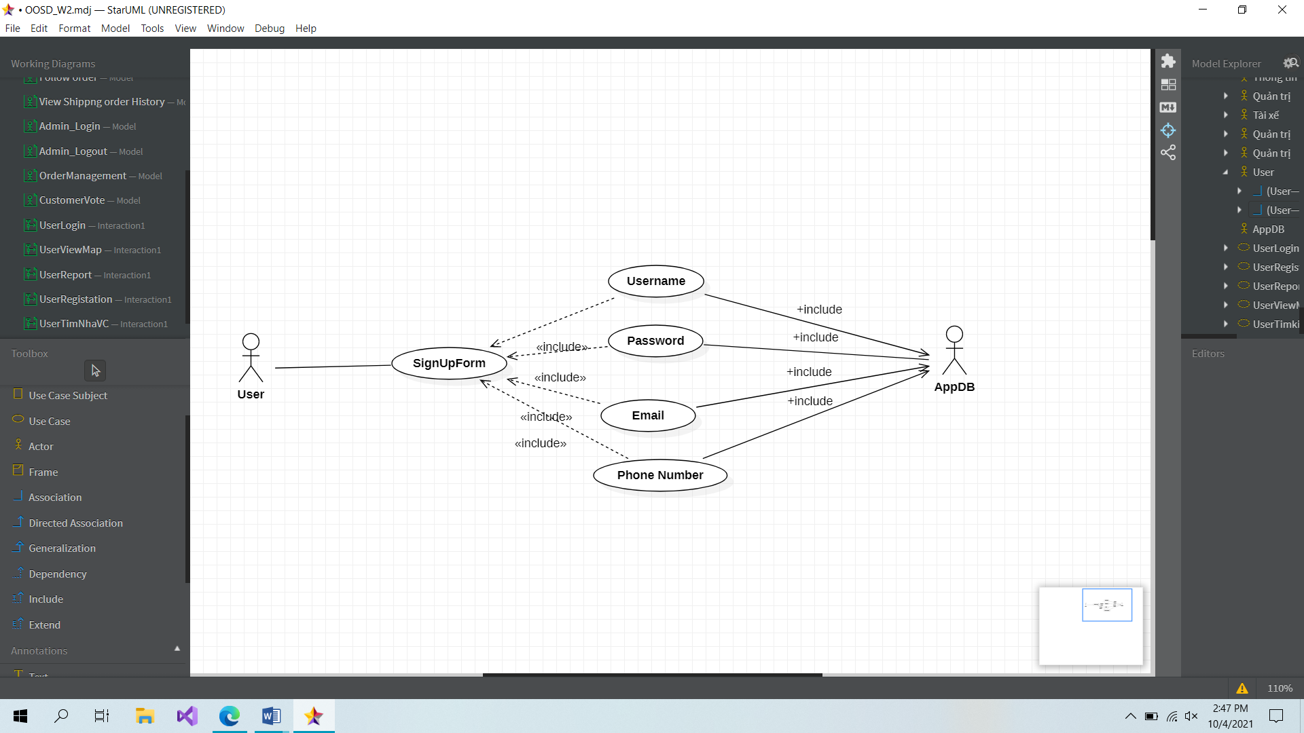

|  |  |
| --- | --- |
| **User usecase SignUp** | |
| **Actors** | User, Database |
| **Description** | An user can create a new account in the system by filling some basic information in sign up form |
| **Data** | Users (database) |
| **Stimulus** | Interface including form and button |
| **Response** | Message: creating a new account successfully |
| **Comments** | The user must input some basic and valid information (username is unique) into the form. In some system, the user may have to verify by using email/phone or to wait for admin’acception |

**User usecase: Search for shipping unit**

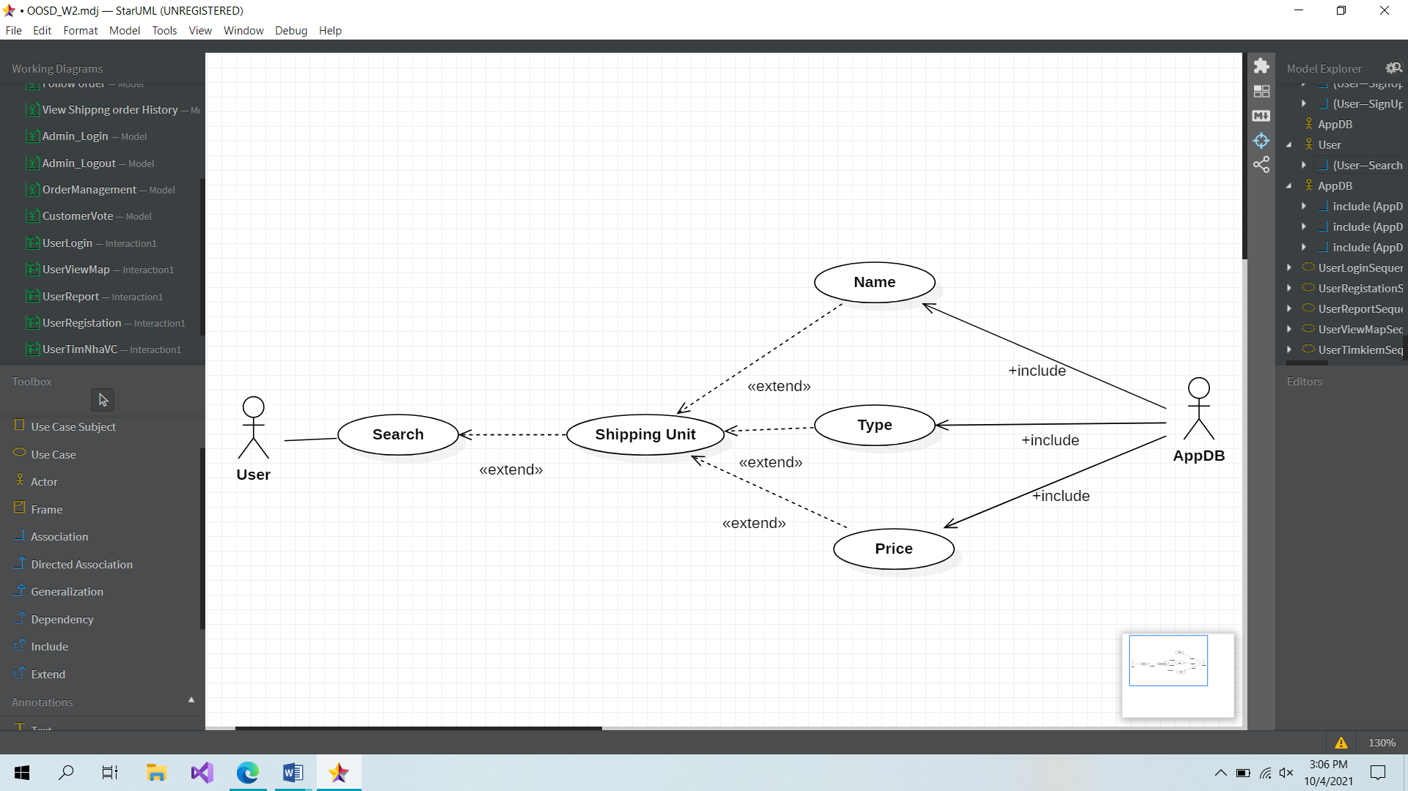

|  |  |
| --- | --- |
| **User usecase: Search for shipping unit** | |
| **Actors** | User, Database |
| **Description** | An user can search for shipping unit in 3 ways: price, name of Shipping Unit and Type of Delivery to booking |
| **Data** | Search (database) |
| **Stimulus** | Interface including the list of results and the button |
| **Response** | Message: There are … results for your requirement. |
| **Comments** | The user may search shipping unit based on their needs in order to booking a shipper to delivery goods. |

**User usecase: Vote or Feedbacks**

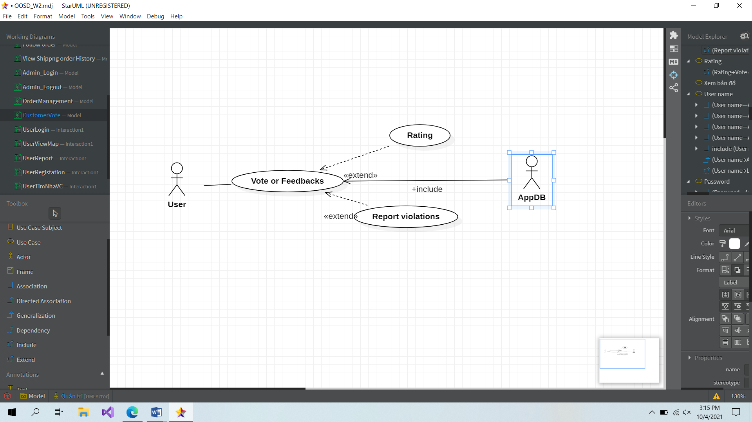

|  |  |
| --- | --- |
| **User usecase: Vote or Feedbacks** | |
| **Actors** | User, Database |
| **Description** | An user input some feedbacks and vote for shipper |
| **Data** | User’s input |
| **Stimulus** | Interface include input form and submit button |
| **Response** | Message: You feedback is received |
| **Comments** | The user must input their felling about the shipper into the form for rating. Some system, users just need input a single line and using submit button in order to send to the system |

**User usecase: Promotion**

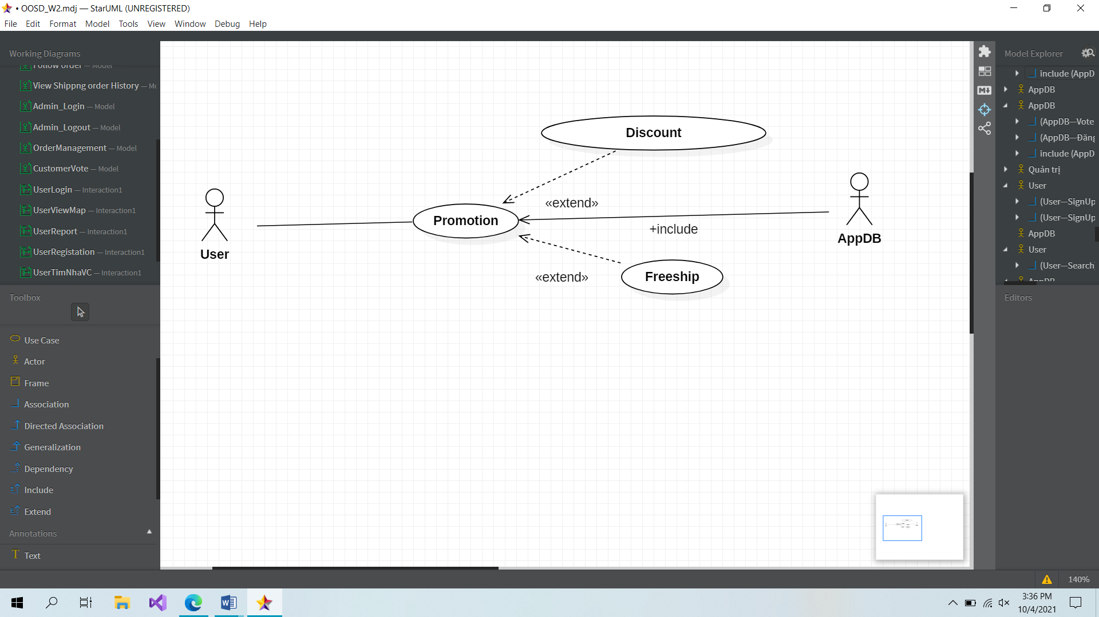

|  |  |
| --- | --- |
| **User usecase: Promotion** | |
| **Actors** | User, Database |
| **Description** | A user can choose promotion in a list of promtion displayed on the screen and then click on button Apply |
| **Data** | User’s choice |
| **Stimulus** | Interface include a list view and button |
| **Response** | Apply promotion successfully |
| **Comments** | The user can choose a promotion or not. It can provide a discount or may be freeship and it helps user save their money |

**User usecase: View map**

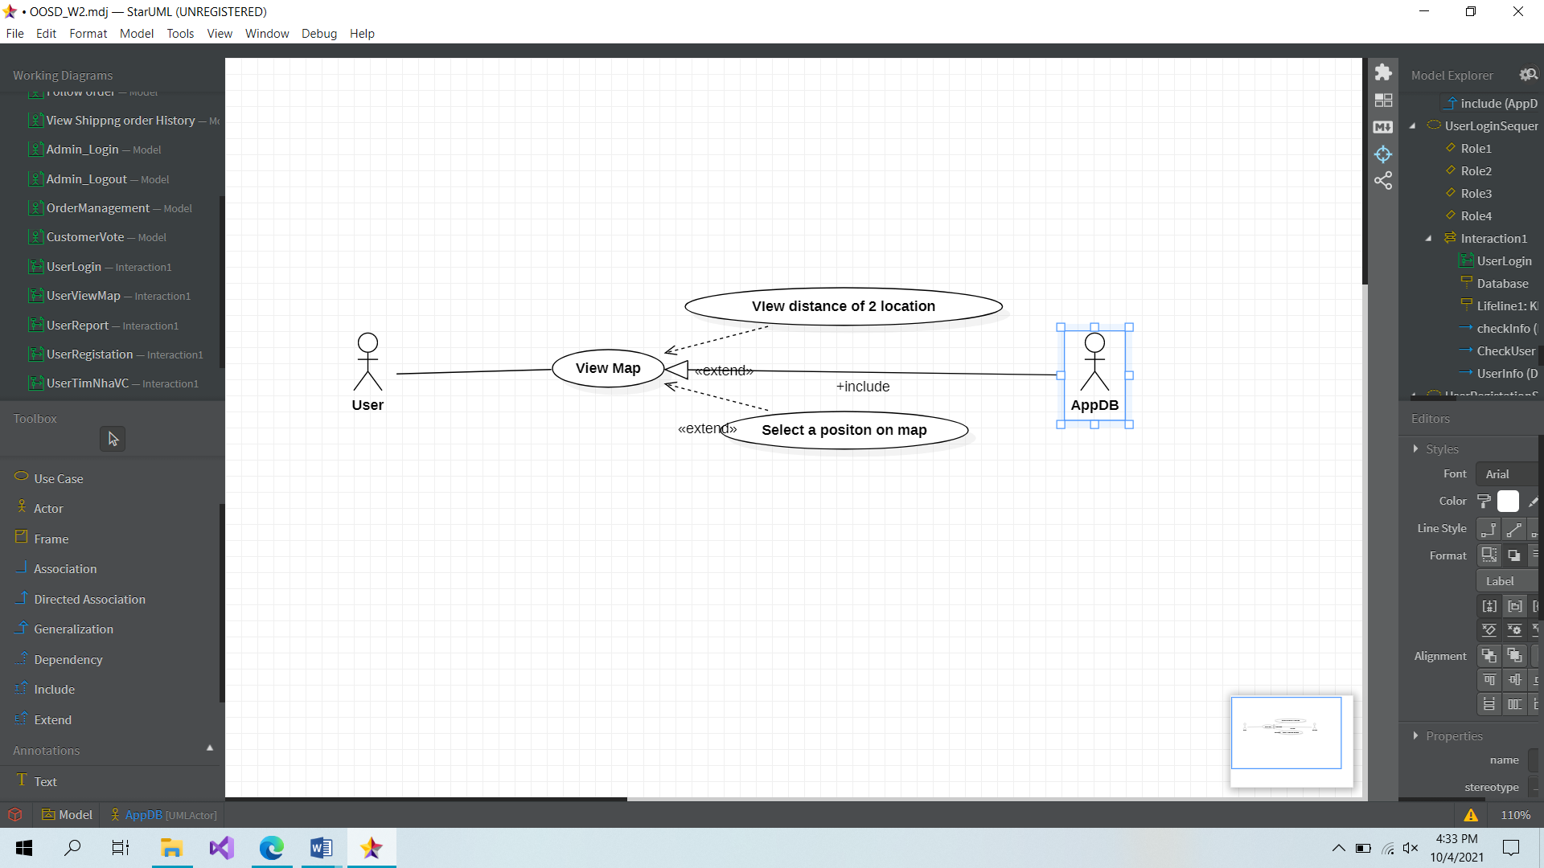

|  |  |
| --- | --- |
| **User usecase: View Map** | |
| **Actors** | User, Database |
| **Description** | User can view the map, manipulate on the map |
| **Data** | User’s input, manipulate |
| **Stimulus** | Interface include input view and button |
| **Response** | The result on the screen |
| **Comments** | The user may use the map to view how far from position A to position B, predict the delivery time, find the shortest way,… |

**User usecase: Order delivery**

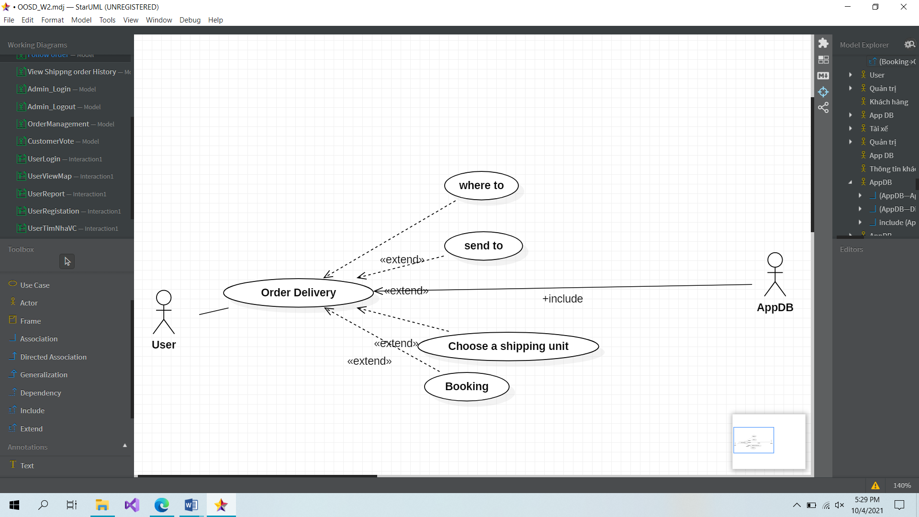

|  |  |
| --- | --- |
| **User usecase: Order Delivery** | |
| **Actors** | User, Database |
| **Description** | User can order a shipper to delivery something they want |
| **Data** | User’s input and submit |
| **Stimulus** | Interface include input form and button |
| **Response** | Successfully Return form |
| **Comments** | The user input 2 locations A, B and choose a shipping unit. After that, press button Booking to order |

**User usecase: Orders’s History**

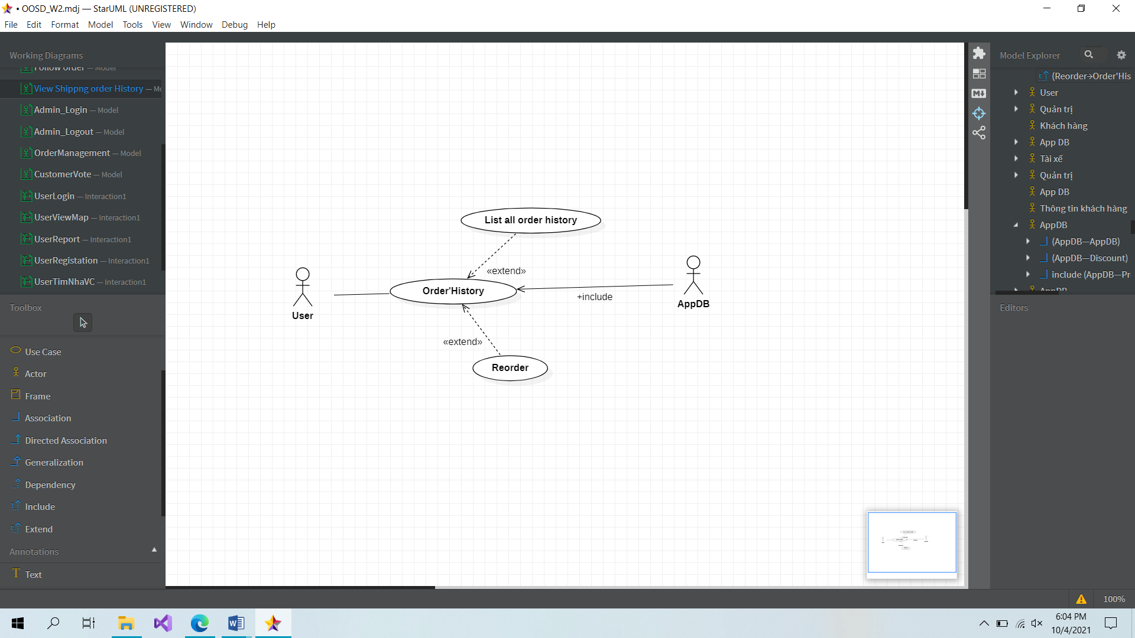

|  |  |
| --- | --- |
| **User usecase: Order History** | |
| **Actors** | User, Database |
| **Description** | All history of ordering of user are stored here |
| **Data** | A list view and button |
| **Stimulus** | Interface include list view and button |
| **Response** | Message: All your finished order here |
| **Comments** | User can see the list of ordering accomplishmented and they can reorder by click Reorder button |

**User usecase: Payment**

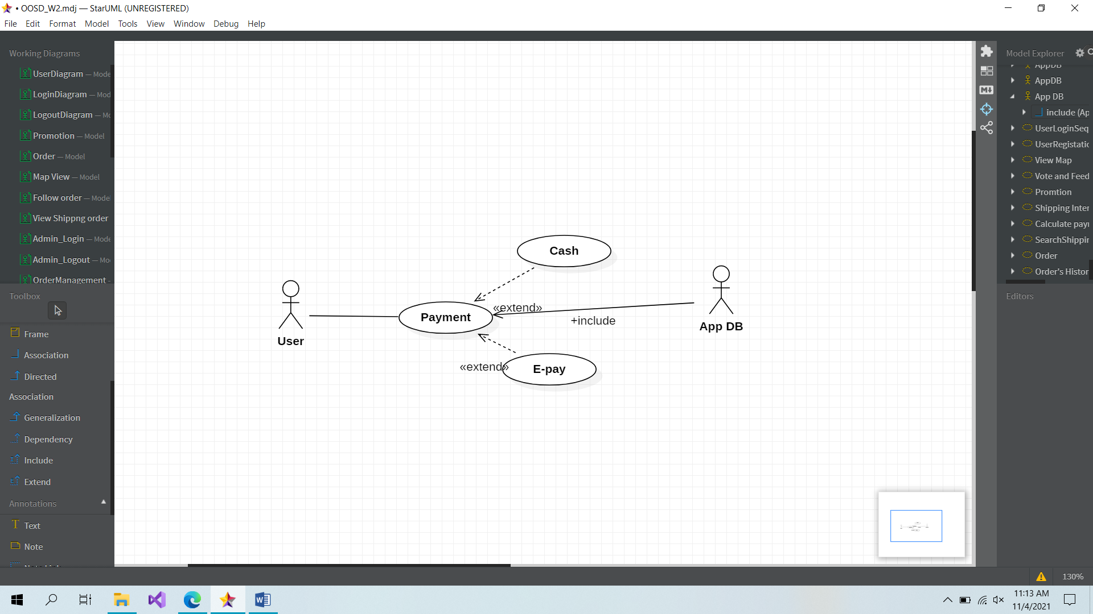

|  |  |
| --- | --- |
| **User usecase: Payment** | |
| **Actors** | User, Database |
| **Description** | Access to Payment form to pay the money |
| **Data** | User choice |
| **Stimulus** | Interface include button and a view form |
| **Response** | Message: Successfully or not |
| **Comments** | The user can use this service to pay for delivery money before shipper starts work |

**SHIPPER SIDE**

**Usecase: Shipper_Login**

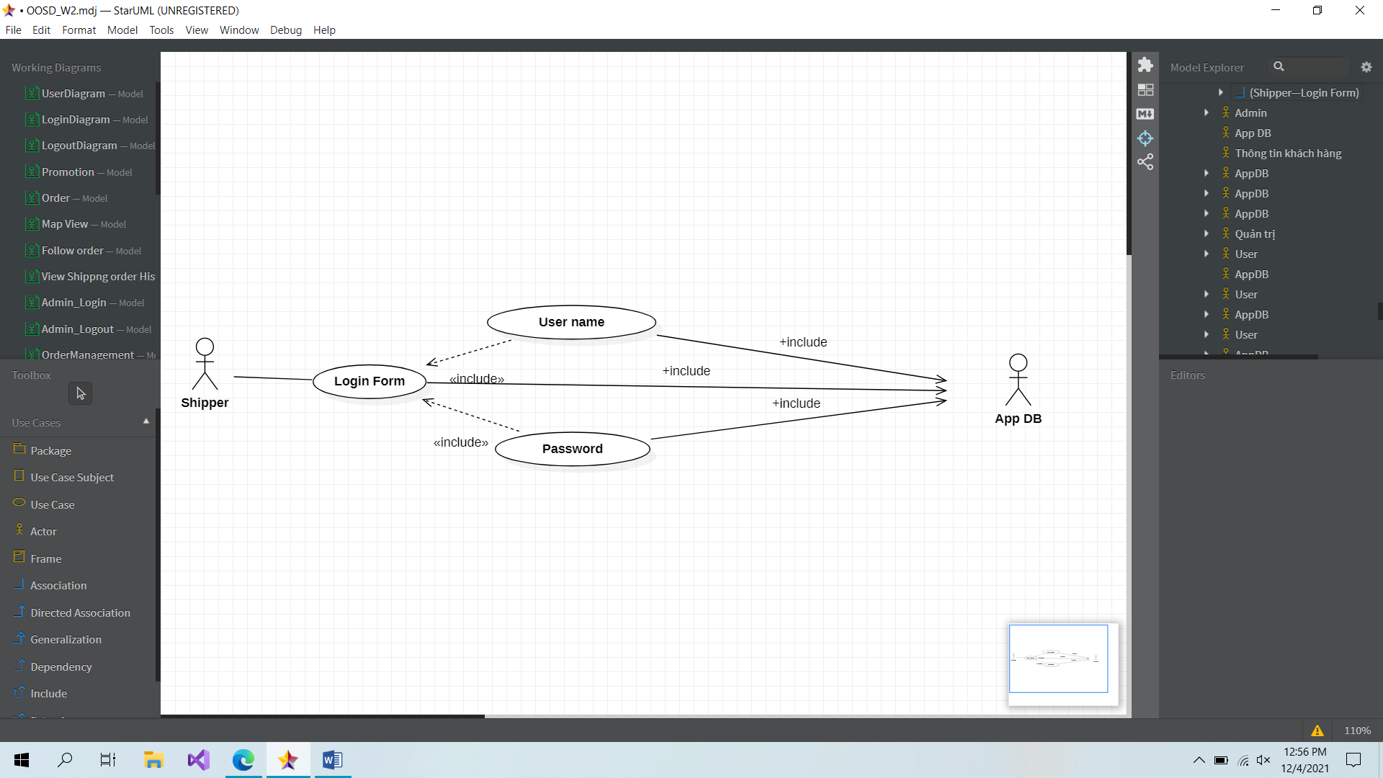

|  |  |
| --- | --- |
| **Shipper usecase Login** | |
| **Actors** | Shipper, Database |
| **Description** | An shipper can log in their account into the system based on database by inputing their username/email and password in the login form |
| **Data** | Shippers (database) |
| **Stimulus** | Interface including form and button |
| **Response** | Shipper’s home page |
| **Comments** | The shipper must have a valid account and input correctly into the form. The shipper may have to confirm their account by using email/phone verification such as phone call, SMS, … in some system |

**Usecase: Login_SignUp**

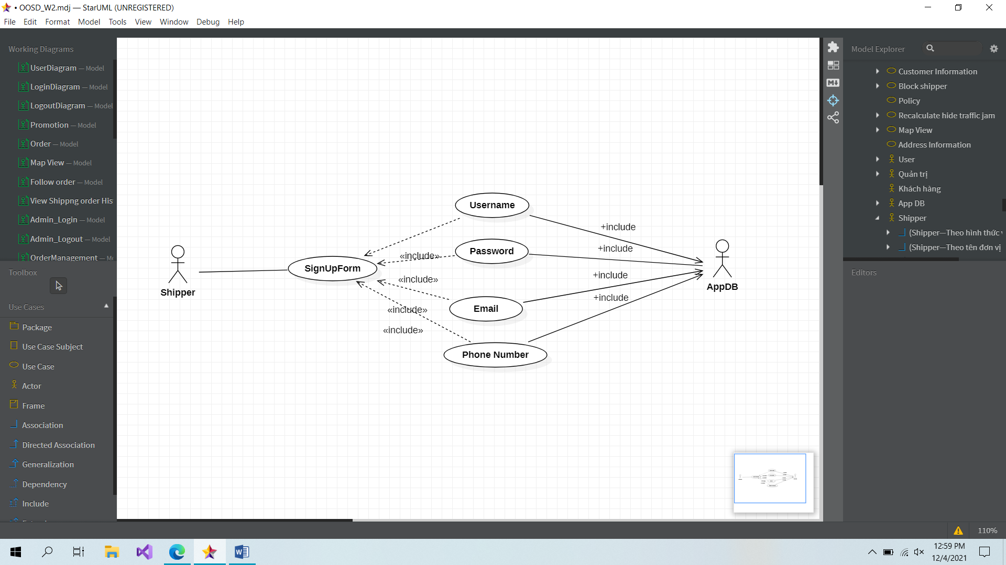

|  |  |
| --- | --- |
| **Shipper usecase SignUp** | |
| **Actors** | Shipper, Database |
| **Description** | An shipper can create a new account in the system by filling some basic information in sign up form |
| **Data** | Shippers (database) |
| **Stimulus** | Interface including form and button |
| **Response** | Message: creating a new account successfully |
| **Comments** | The shipper must input some basic and valid information (username is unique) into the form. In some system, the shipper may have to verify by using email/phone or to wait for admin’acception |

**Usercase: Add another location**

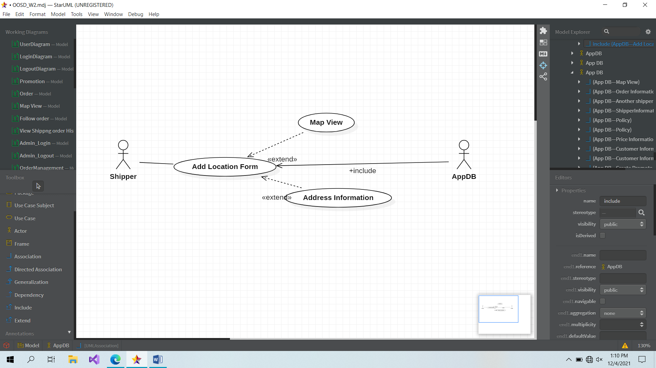

|  |  |
| --- | --- |
| **Shipper usecase: Add another location** | |
| **Actors** | User, Database |
| **Description** | Shipper can add more location in their delivery way if it is neccessay for them or if they think that it will help them to be faster |
| **Data** | Shipper’s input |
| **Stimulus** | Interface that is the map and button to add another location |
| **Response** | The list of shipper and button |
| **Comments** | The user can use this form to find and call for another’s shipper help in case can not finish the order |

**Usercase: Deliver many orders**

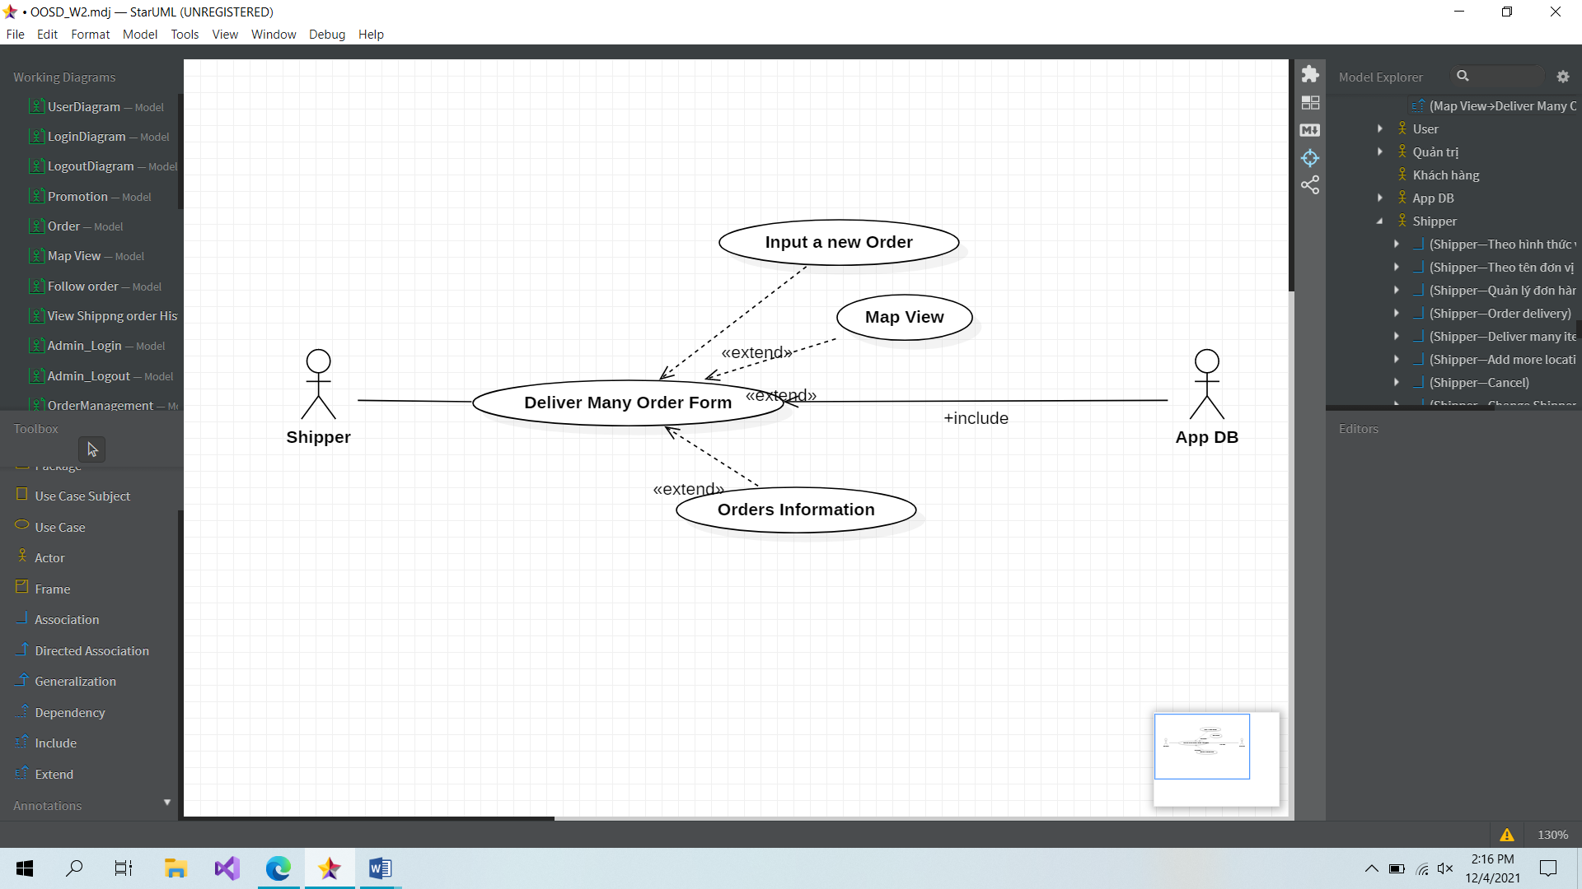

|  |  |
| --- | --- |
| **Shipper usercase: Deliver many orders** | |
| **Actors** | User, Database |
| **Description** | Shipper can choose to deliver many items from many customer if they or on the same ways but at most 5 location in each shipping |
| **Data** | Shipper DB, Shipper’s input |
| **Stimulus** | Interface include input form and submit butotn |
| **Response** | Add adress successfully |
| **Comments** | The shipper can use this form to add another address so it can help them to deliver many location |

**Usercase: Shipper_Calculate the shortest way to deliver in fastest way**

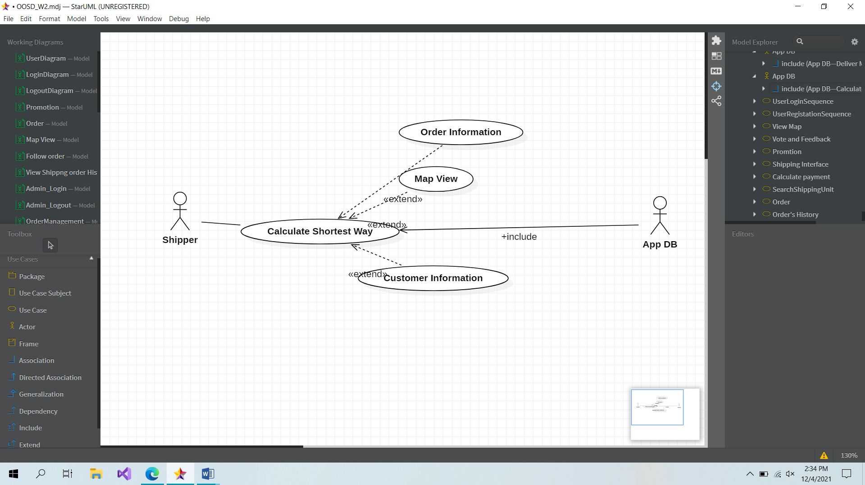

|  |  |
| --- | --- |
| **Shipper usercase: Calculate the shortest way to deliver in fastest way** | |
| **Actors** | Shipper, Database |
| **Description** | System will calculate the shortest and the fastest way to help shipper deliver items as fast as possible and base on that system can calculate the estimate time for shipment. |
| **Data** | Database, |
| **Stimulus** | Interface include input form and addfriend button |
| **Response** | Successfully added your new friends |
| **Comments** | The user can addfriend in order to share experience and create motivation when competing with your friend |

**Usercase: Shipper_CancelOrder**

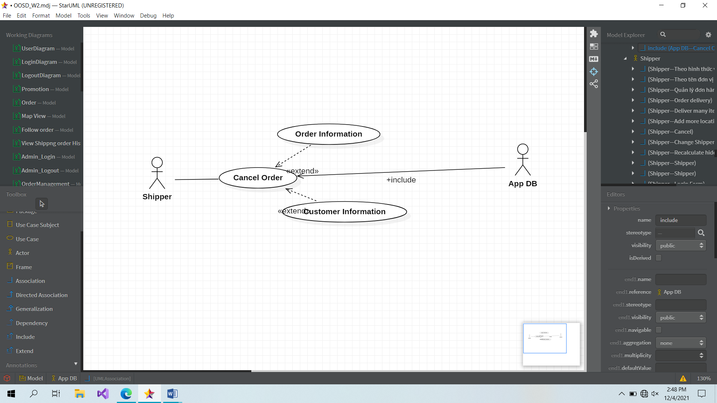

|  |  |
| --- | --- |
| **Shipper Usercase: CancelOrder** | |
| **Actors** | User, Database |
| **Description** | Shipper can cancel order if they can not contact to customer after they reached the sender address or waiting time is more than 5 minutes or customer asked for cancellation. |
| **Data** | Shipper’s manipulate |
| **Stimulus** | Cancel button |
| **Response** | Canceled Order |
| **Comments** | The shipper can cancel order in case cannot connnect to customer,… in order to stop and start another order |

**Usecase: Shipper_RecalculateWaytoAvoidJam**

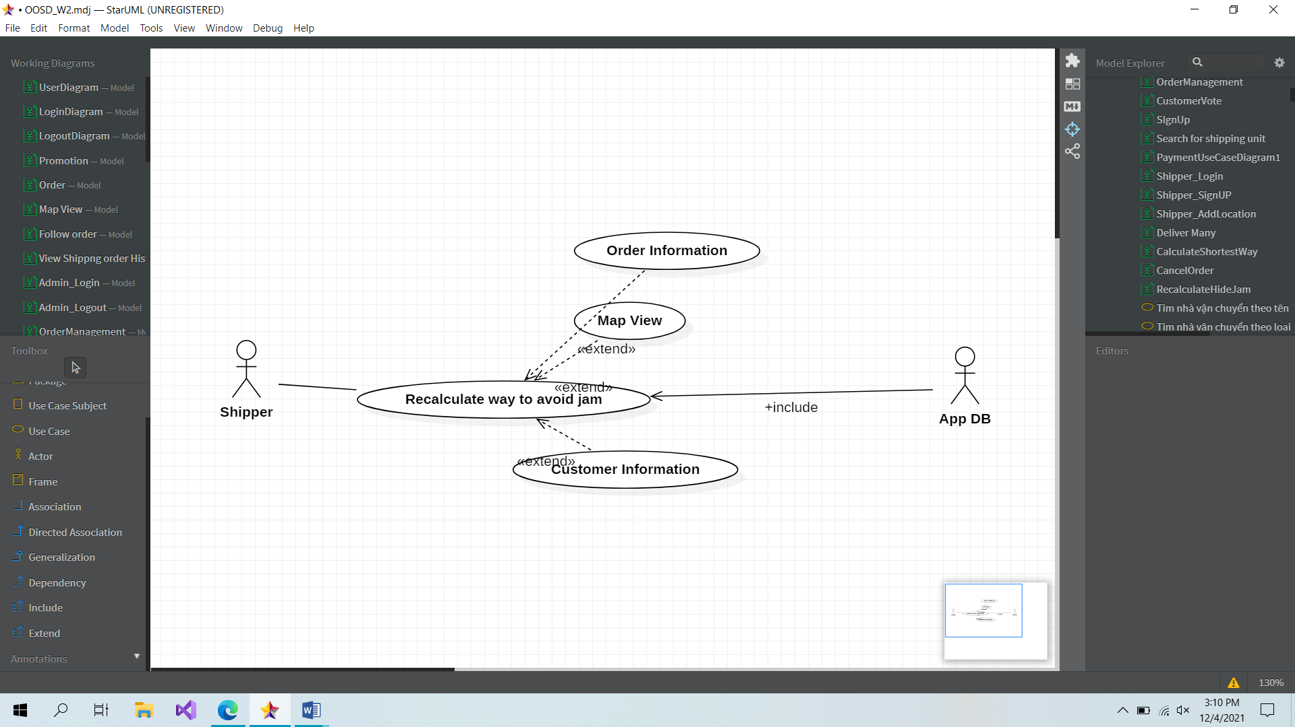

|  |  |
| --- | --- |
| **Shipper Usecase: Recalculate way to avoid traffic jam** | |
| **Actors** | Shipper |
| **Description** | If customer is on the way to deliver items but system find out that shipper is stuck at that street in 5-10 minutes so system need to re-calcualate the delivery way again and help customer to get out that traffic jam. |
| **Data** | Shipper’s Manipulate |
| **Stimulus** | Interface contains map, button |
| **Response** | Show result in map |
| **Comments** | Shipper can view on map and decide another way to deliver instead of continuing on the crowded way |

**Usecase: Shipper_ChangeShipper**

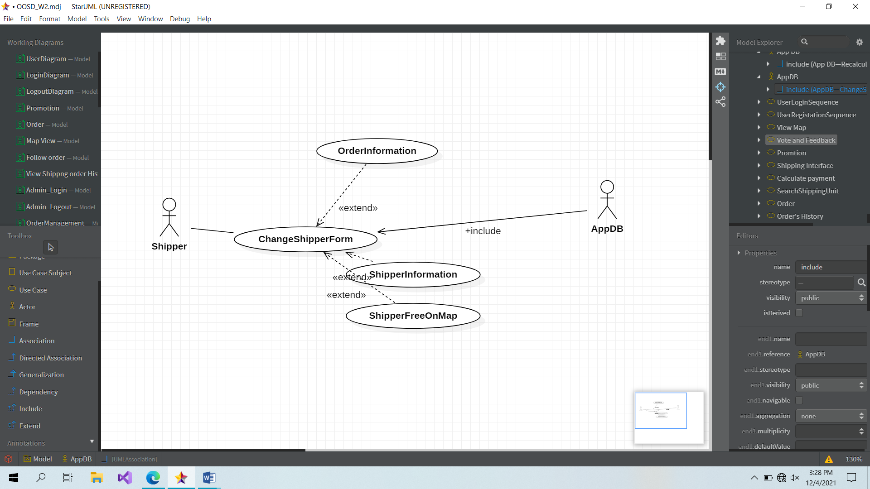

|  |  |
| --- | --- |
| **Shipper Usecase: Change Shipper** | |
| **Actors** | User |
| **Description** | After get items from customer, if shipper can not continue to delivery or they have any problem, violate with time policy of shipment, shipper can request system to find out other nearest shipper can help them to continue their job. |
| **Data** | Shipper’s button to find another one who is free to help finish the delivery |
| **Stimulus** | Interface has button to find another shipper, button to contact |
| **Response** | Show the list the shipper is in free time |
| **Comments** | Shipper use this to call for help from another one in case they cannot continue to delivery |

**ADMIN SIDE**

**Usercase: Admin_Login**

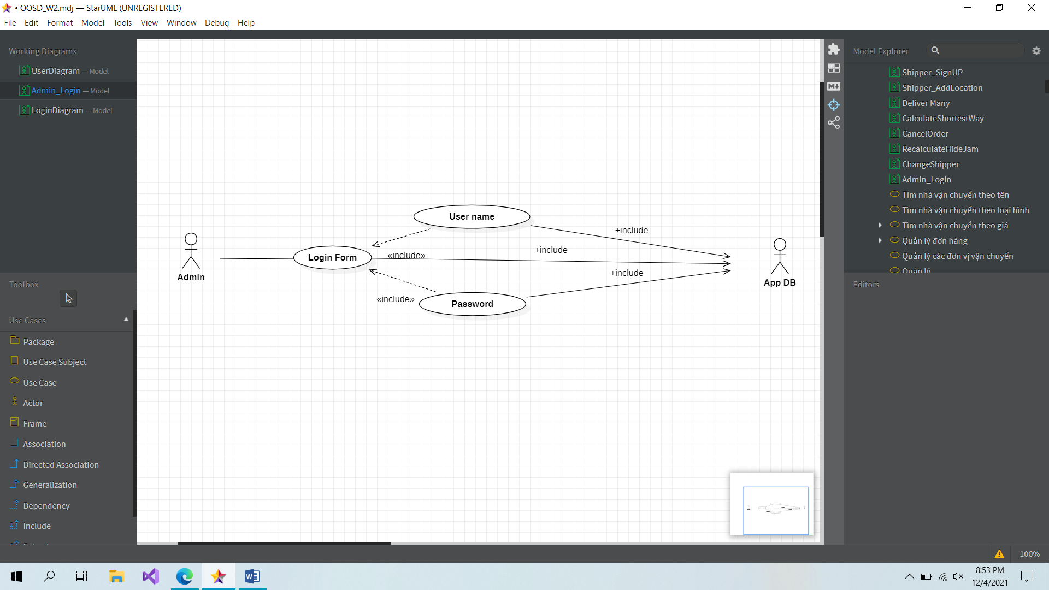

|  |  |
| --- | --- |
| **Admin usercase: Login** | |
| **Actors** | Admin, Database |
| **Description** | An admin can log in their account into the system based on database by inputing their username/email and password in the login form |
| **Data** | Admin (database) |
| **Stimulus** | Interface including form and button |
| **Response** | Admin’s home page |
| **Comments** | The admin must have a valid account and input correctly into the form. The admin may have to confirm their account by using email/phone verification such as phone call, SMS, … in some system |

**Usercase: Admin_SignUp**

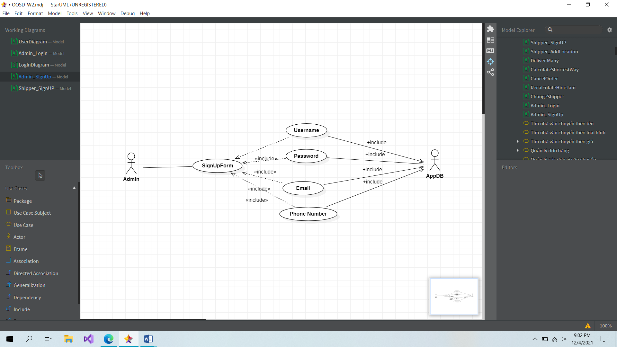

|  |  |
| --- | --- |
| **Admin usercase: Sign Up** | |
| **Actors** | Admin, Database |
| **Description** | An admin can create a new account in the system by filling some basic information in sign up form |
| **Data** | Admin (database) |
| **Stimulus** | Interface including form and button |
| **Response** | Message: creating a new account successfully |
| **Comments** | The admin must input some basic and valid information (username is unique) into the form. In some system, the admin may have to verify by using email/phone or to wait for admin’acception |

**Usercase: Admin_Manage Shipper Information**

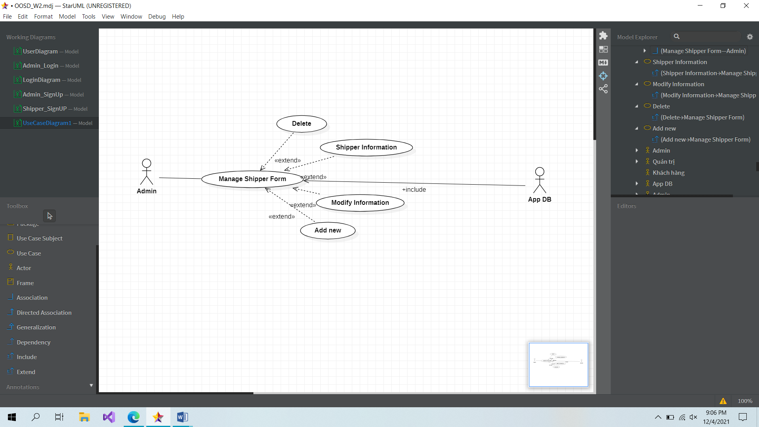

|  |  |
| --- | --- |
| **Admin usercase: Manage Shipper Information** | |
| **Actors** | Admin, Database |
| **Description** | Admin can get all of information of shipper in the database to manage them. Show out good shipper and bad shipper to have suitable solution to enhance the shipping policy. This also help admin can manage the personal information of shipper and it will neccesary in some cases. For example: Contact with family when shipper get accident, send information to police if shipper steal goods from customer and hide away. |
| **Data** | Admin (database) |
| **Stimulus** | Interface including form and button |
| **Response** | Admin’s home page |
| **Comments** | The admin use this form to manage shipper information with the data of shipper from DB and also can add, delete and modify |

**Usercase: Admin_Manage Customer Information**

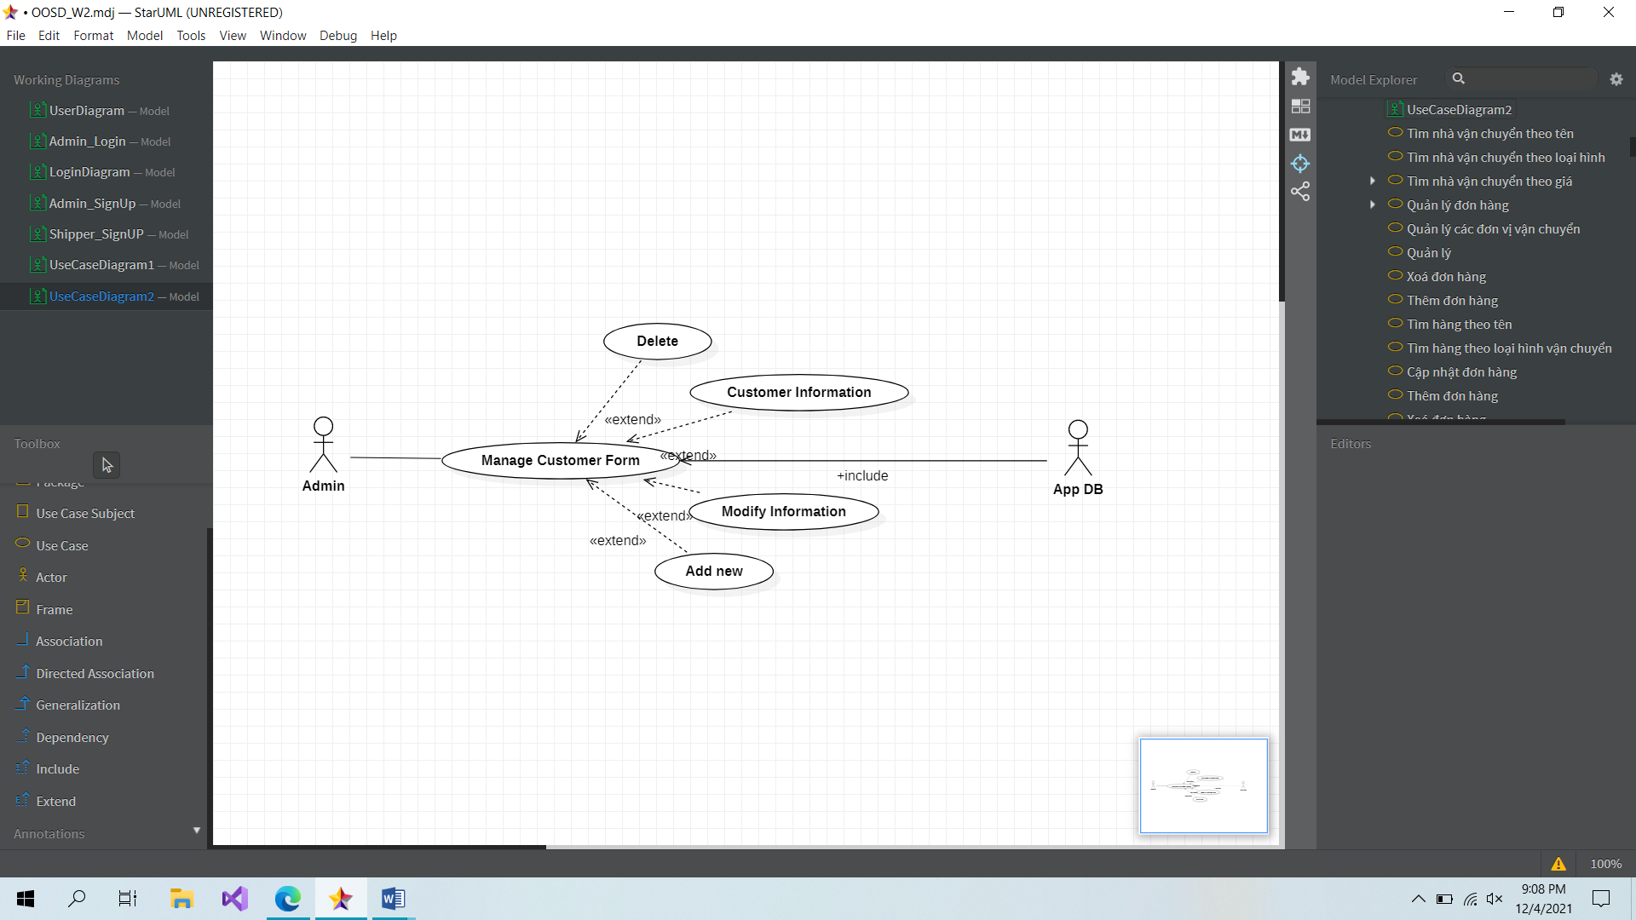

|  |  |
| --- | --- |
| **Admin usercase: Manage Customer Information** | |
| **Actors** | Admin, Database |
| **Description** | Admin can get all of information of customer including: Name, address, phone number and number of using system from that customer. This is not only help admin can manage customer but also help them to find out the potential customer. |
| **Data** | Admin (database) |
| **Stimulus** | Interface including form and button |
| **Response** | Admin’s home page |
| **Comments** | The admin use this form to manage customer information with the data of customer from DB and also can add, delete and modify |

**Usercase: Admin_Modify Shipping Price**

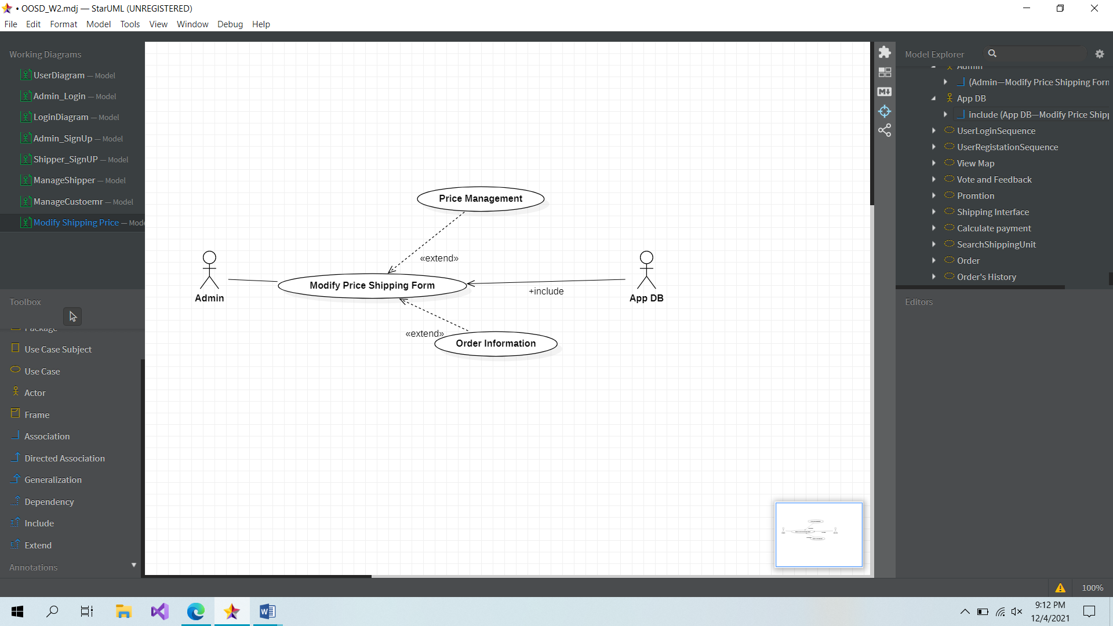

|  |  |
| --- | --- |
| **Admin usercase: Modify Shipping Price** | |
| **Actors** | Admin, Database |
| **Description** | The administrator can change the cost of shipping based on the policy of shipping and price of fuel. They can change the price per km or price per hour of shipping or the transport type. |
| **Data** | Admin (database) |
| **Stimulus** | Interface including form and button |
| **Response** | Admin’s home page |
| **Comments** | The admin use this site to modify the shipping price with the data of Order and Price in Database |

**Usercase: Admin_Add new shipper or admin into the system**

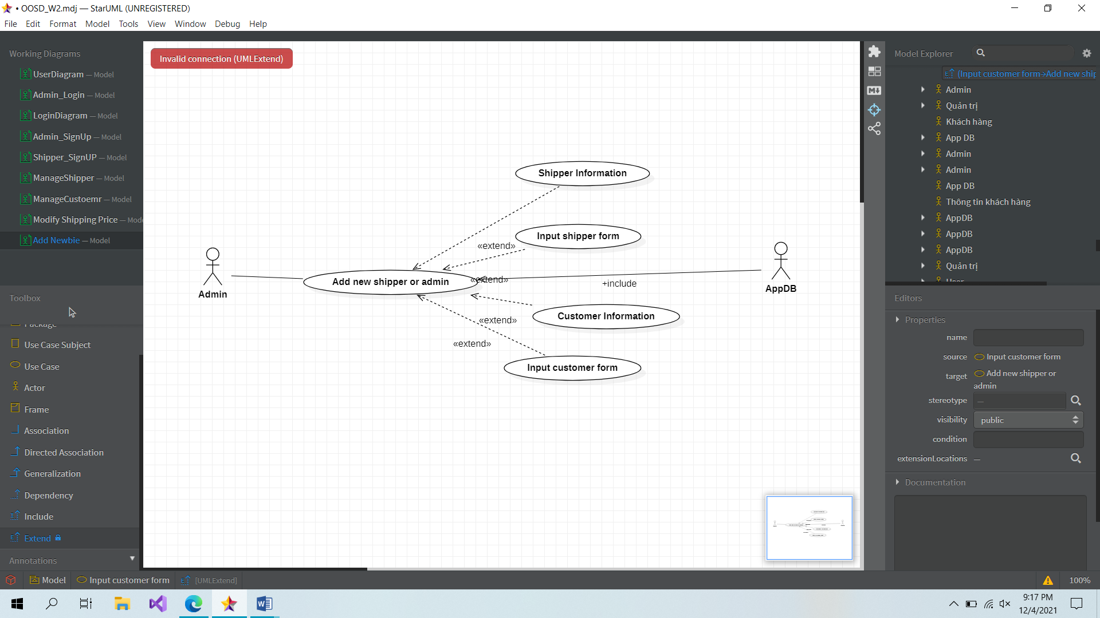

|  |  |
| --- | --- |
| **Admin usercase: Add new shipper or admin into the system** | |
| **Actors** | Admin, Database |
| **Description** | Sign up function of the system can not apply for admin and shipper because of the security problem so that it need to be added by administration. |
| **Data** | Admin (database) |
| **Stimulus** | Interface including form and button |
| **Response** | Admin’s add newbie page |
| **Comments** | The admin use this to add a new shipper or a new administrator into the database |

**Usercase: Admin_Send Invoice via customer Email**

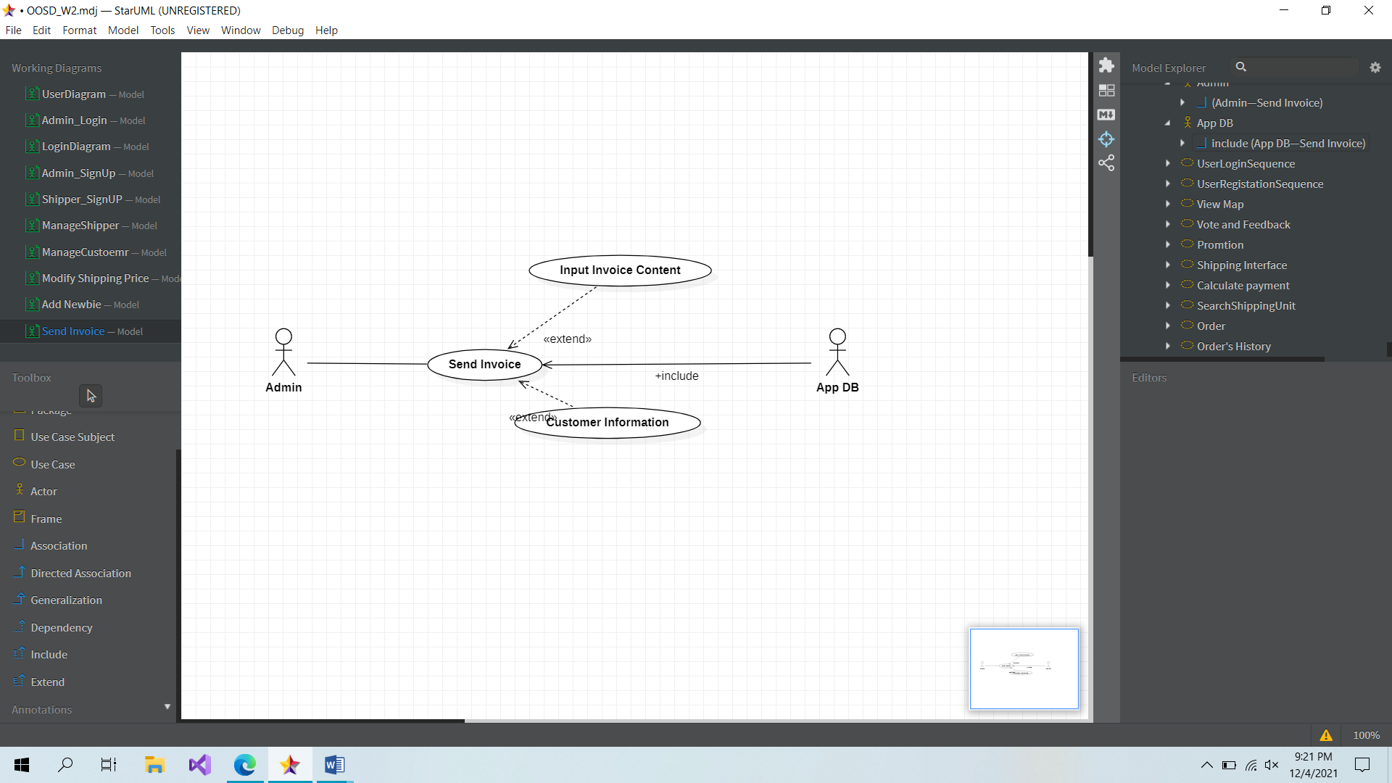

|  |  |
| --- | --- |
| **Admin usercase: Send Invoice via customer Email** | |
| **Actors** | Admin, Database |
| **Description** | Admin will send the invoice to customer when the order was finished |
| **Data** | Admin (database) |
| **Stimulus** | Interface including form and button |
| **Response** | Admin’s invoice page |
| **Comments** | The admin use this page send invoice to the customer through Email |

**Usercase: Admin_Block Shipper**

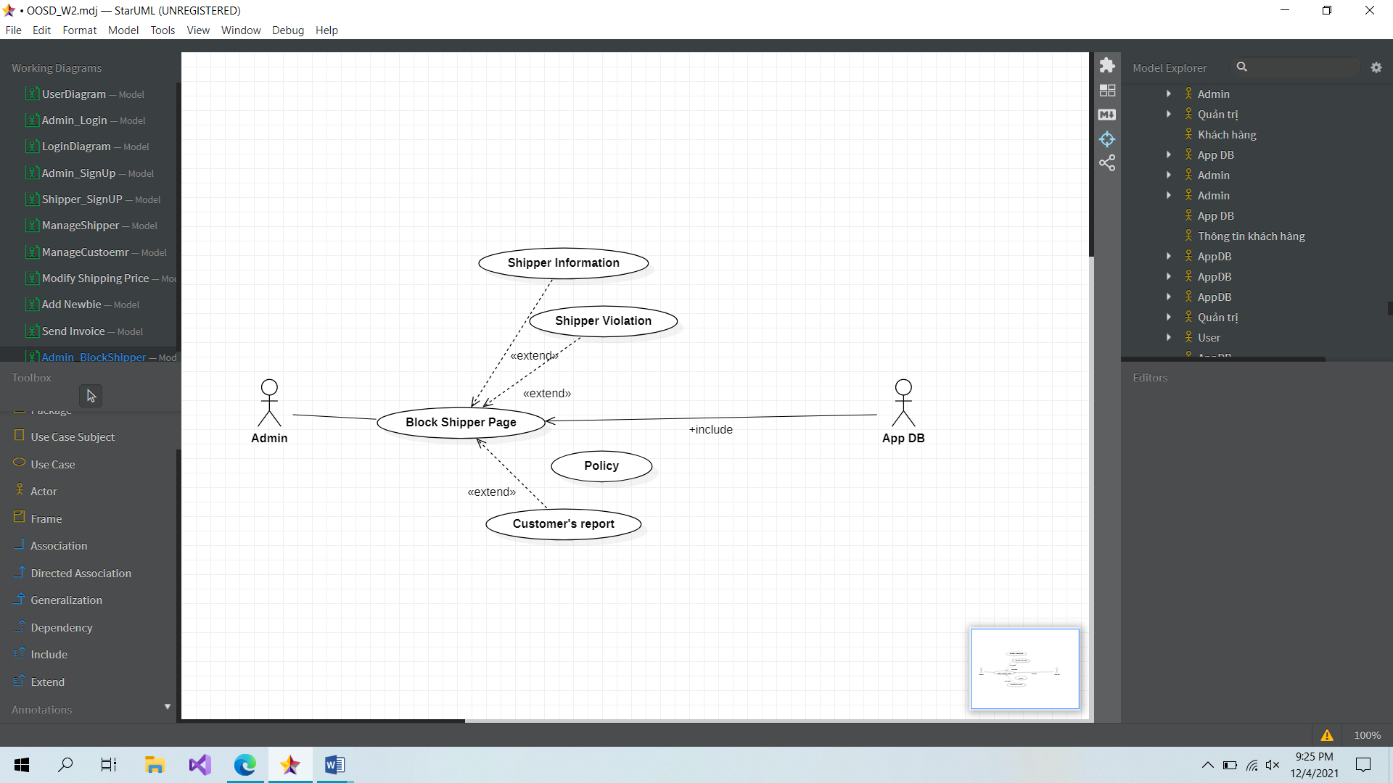

|  |  |
| --- | --- |
| **Admin usercase: Block Shipper** | |
| **Actors** | Admin, Database |
| **Description** | If shipper infringed the policy of shipment, admin can block their account. |
| **Data** | Admin (database) |
| **Stimulus** | Interface including form and button |
| **Response** | Admin’s block shipper page |
| **Comments** | The admin has to block shipper in some case, admin can use this page to do it. |

**Usercase: Admin_BlockCustomer**

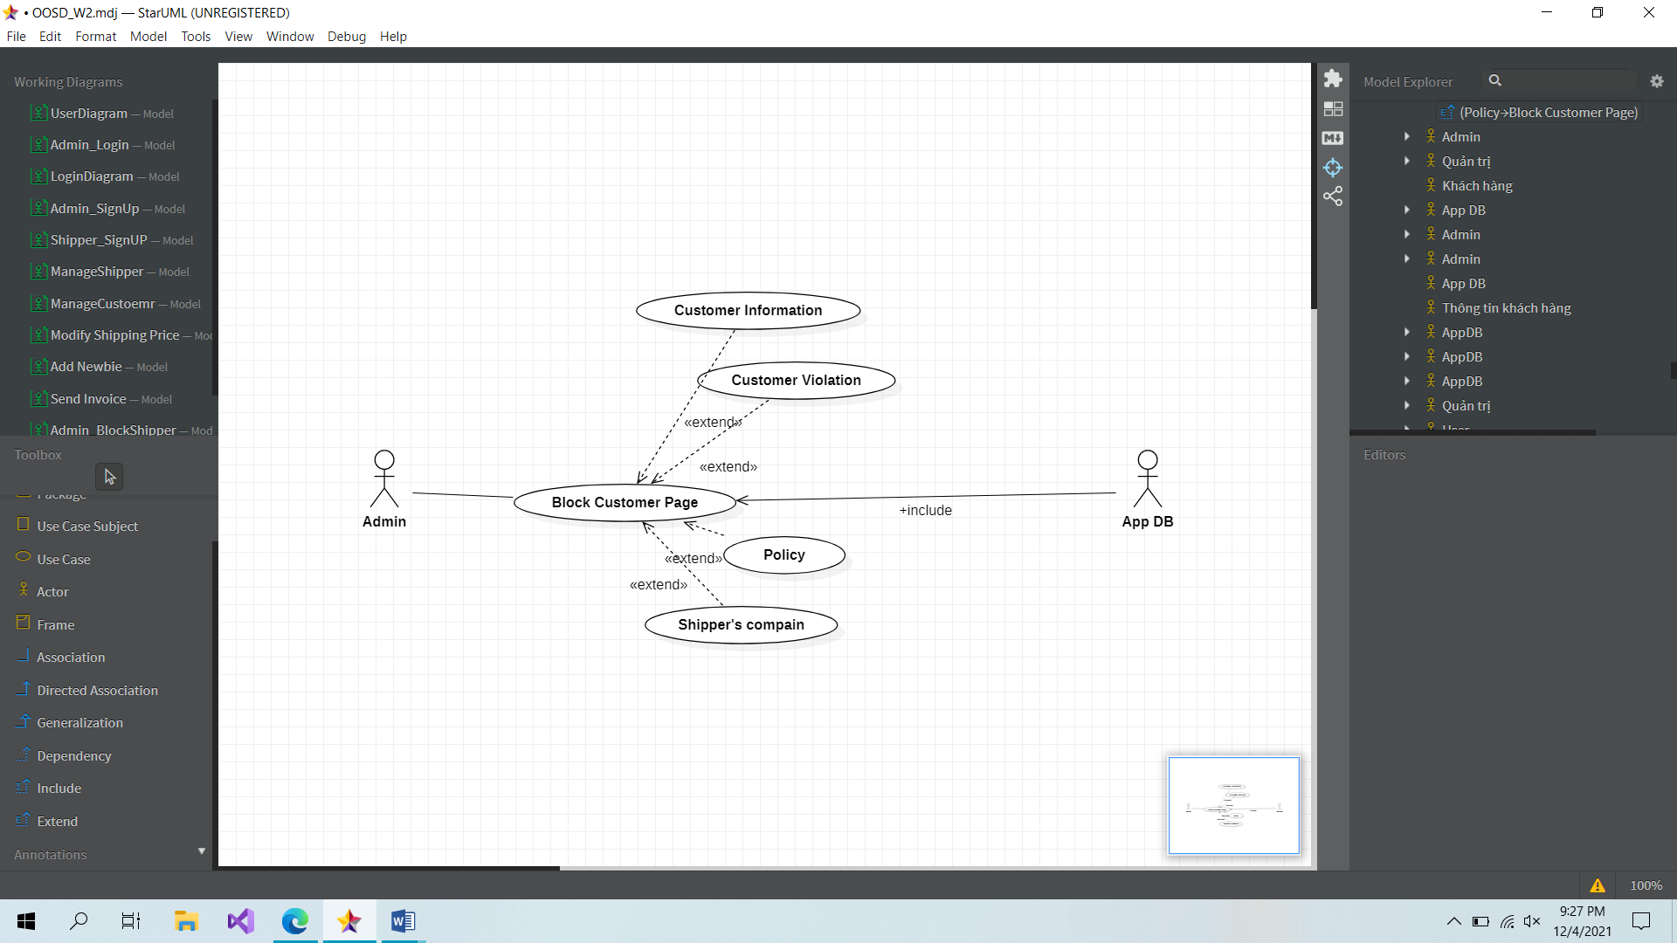

|  |  |
| --- | --- |
| **Admin usercase: BlockCustomer** | |
| **Actors** | Admin, Database |
| **Description** | If customer infringed the policy of shipment, admin can block their account. |
| **Data** | Admin (database) |
| **Stimulus** | Interface including form and button |
| **Response** | Admin’s block customer page |
| **Comments** | The admin has to block customer in some case, admin can use this page to do it according shipper’s report, … |

**Usercase: Admin_Send Promote to Customer**

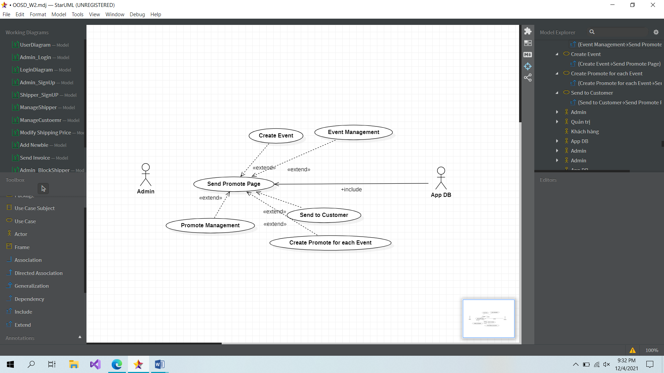

|  |  |
| --- | --- |
| **Admin usercase: Send Promote to Cusomer** | |
| **Actors** | Admin, Database |
| **Description** | Admin send promotions code to customer |
| **Data** | Admin (database) |
| **Stimulus** | Interface including form and button |
| **Response** | Admin’s promote page |
| **Comments** | The admin can manage promote and also add or delete the event provided promote to customer |